Setup for Fellowship Online

Although setup and installation are easy, you may want to print this page for a step-by-step guide.

Once you have the FirstClass Client installed, logging in to FOL is quick and easy. Just launch the FirstClass Program and choose File...New, and type in the name FOL. You will then see the Service Setup screen:

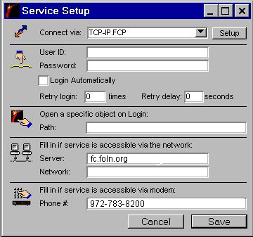

Fill in the following Information:
Server: fc.foln.org
Phone #: 972-783-8200

If you wish, you can Enter and Save your User ID and Password now, in the login script. However, if you save this information here, anyone with access to your computer can log in to your account. You'll have another opportunity to enter this information that will be more secure.

In the Connect Via area at the top of the Service Setup window, choose TCP/IP if you'll be logging in over the internet, or MODEM for a direct-dial connection...click on the Setup button and you will see one of the screens as shown below. Once Setup, just Login to create your account!

------------------------------------------------------------------------

* Setup for TCP/IP access (internet)

By default, the Protocol should be TCP/IP. Click on the arrow next to Advanced Settings, and change the TCP Port to 510. When you've finished setting up the TCP-IP settings, choose Save.

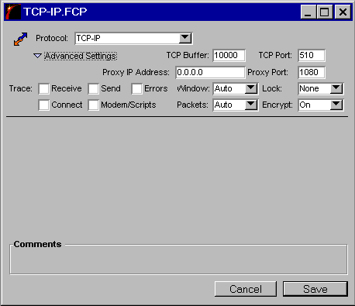

------------------------------------------------------------------------

* Setup for MODEM access (direct-dial)

By default, the Protocol should be Serial. Click on the down-arrow for Modem to choose your modem from the pop-up list. Be sure that the Port setting matches the Com Port set up for your modem on your computer. The correct settings for Cable Options and Speed Options should set automatically. When you've finished the modem settings, choose Save.

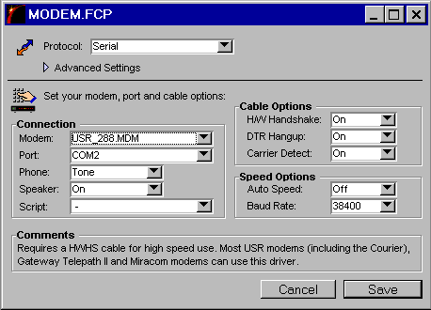

Now you're ready to Login to Fellowship Online
------------------------------------------------------------------------
Although setup and installation are easy, you may want to print this page for a step-by-step guide.

